Name: Varia Neel Jitesh
Enrollment No: 250447003019

Artificial Intelligence - Labs
Lab Sessions
Q1. On Syllabus record: Python: Setting up Environment, Working with NumPy, Pandas and Matplotlib
- Aim: To set up Python environment with Anaconda and perform basic data analysis using NumPy, Pandas, and Matplotlib on a sample dataset.
- Materials Used: Anaconda distribution, Jupyter Notebook, sample CSV dataset (e.g., Iris data).
- Procedure: Install Anaconda, create environment, launch Jupyter, load data with Pandas, compute statistics with NumPy, visualize with Matplotlib histograms and scatter plots.
- Result: Students master Python setup and data manipulation/visualization workflow.

Code:
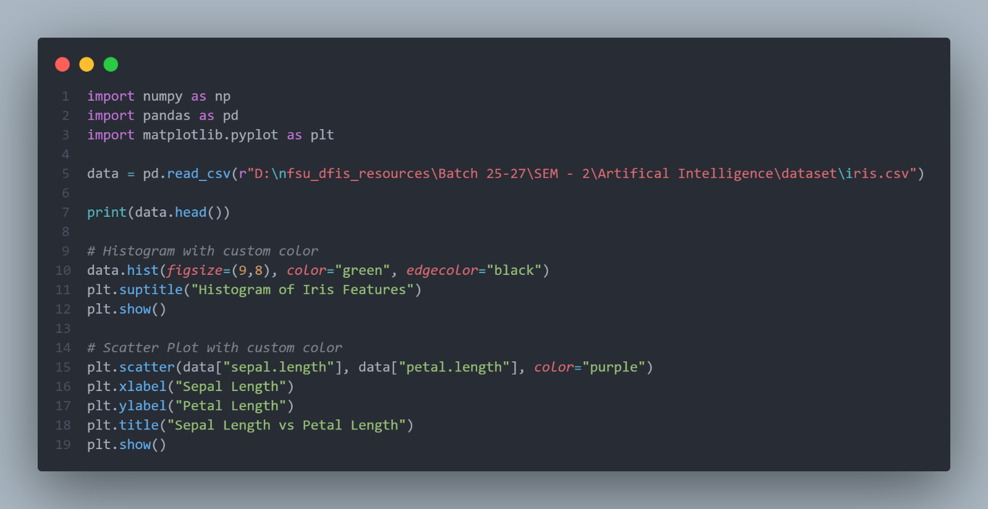

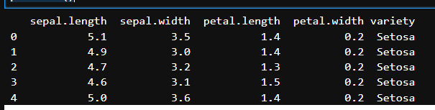

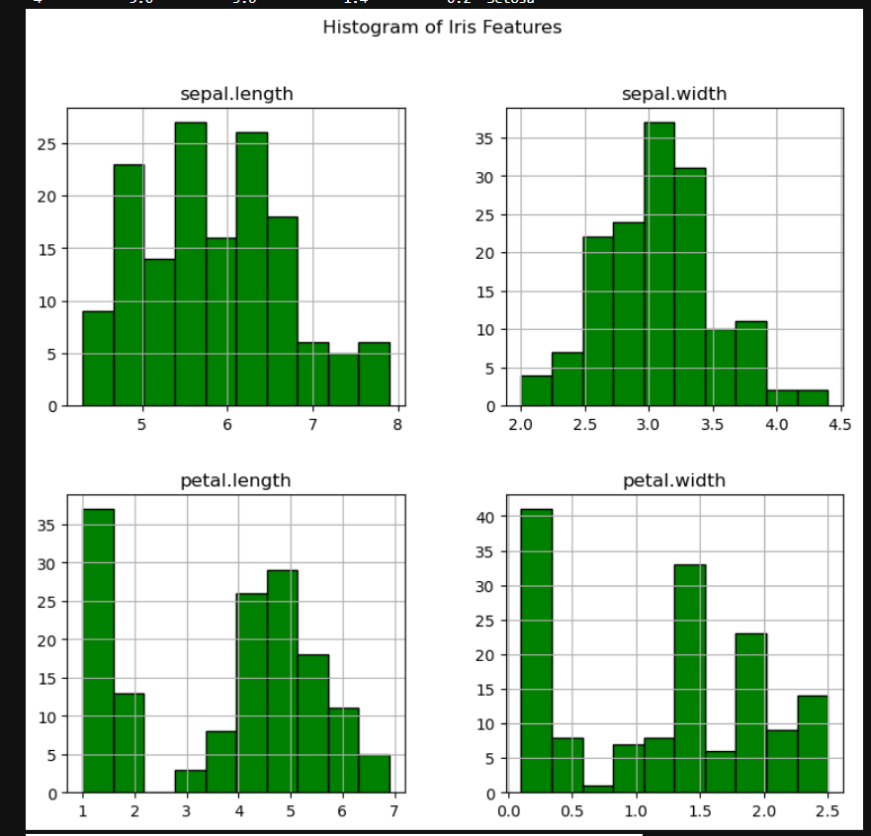

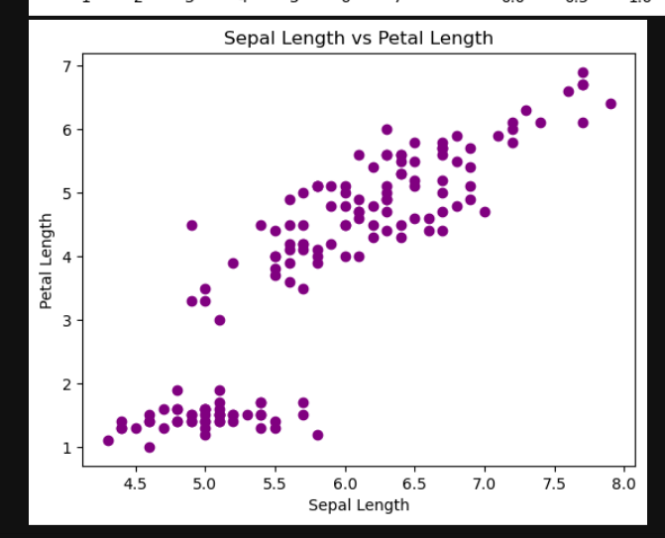
Q2. On Syllabus record: Mathematics for ML: Vectors, Matrices, Linear Equations, Mean, Median, Standard Deviation
- Aim: To implement vector/matrix operations and basic statistics using NumPy for data preprocessing.
- Materials Used: Python (NumPy), Jupyter Notebook, synthetic dataset of vectors/matrices.
- Procedure: Create arrays, perform dot products and matrix multiplication, solve linear equations, calculate mean/median/std/variance on dataset columns.
- Result: Students apply mathematical foundations to real data handling in ML preparation.

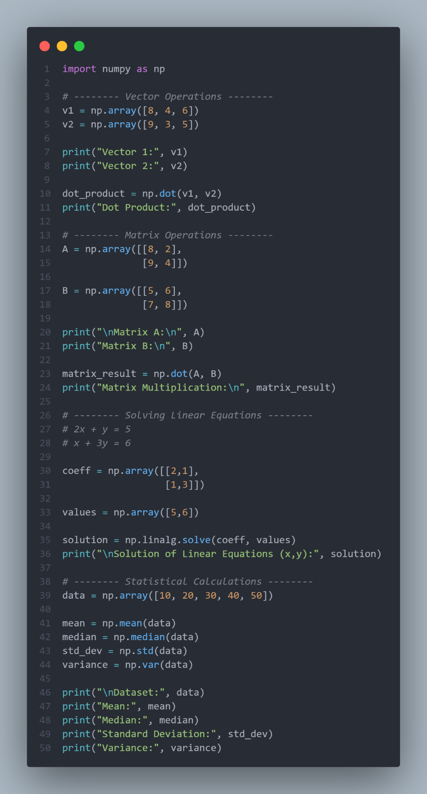
Output:
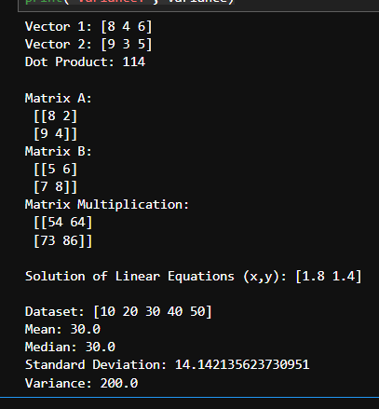

Q3. On Syllabus record: Basics of Supervised Learning, Feature Selection, Normalization, Training/Testing Sets
- Aim: To preprocess a dataset, select features, normalize data, and train a basic supervised model with train-test split.
- Materials Used: Python (scikit-learn, Pandas), public dataset like Wine quality CSV.
- Procedure: Load data, perform feature selection via correlation, normalize with StandardScaler, split into train/test sets, train logistic regression model.
- Result: Students understand supervised learning pipeline from data prep to model training.
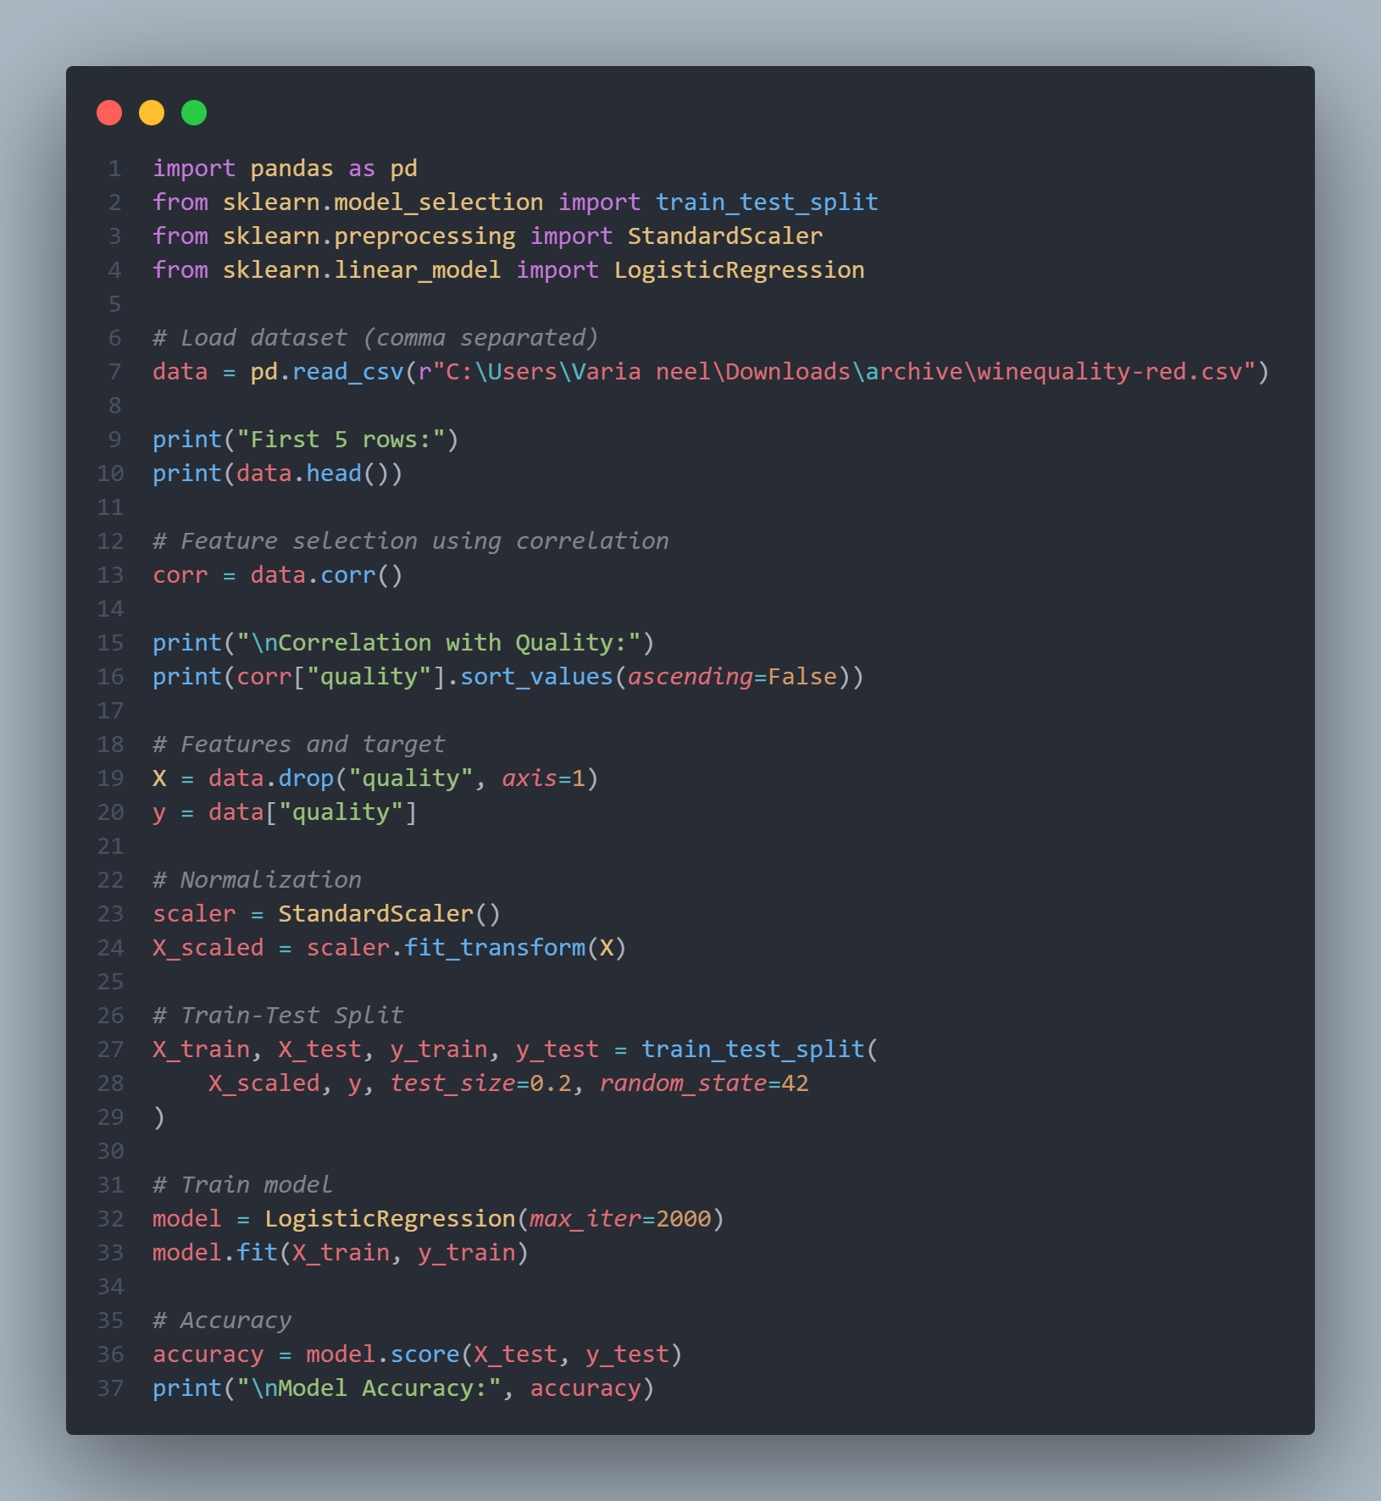

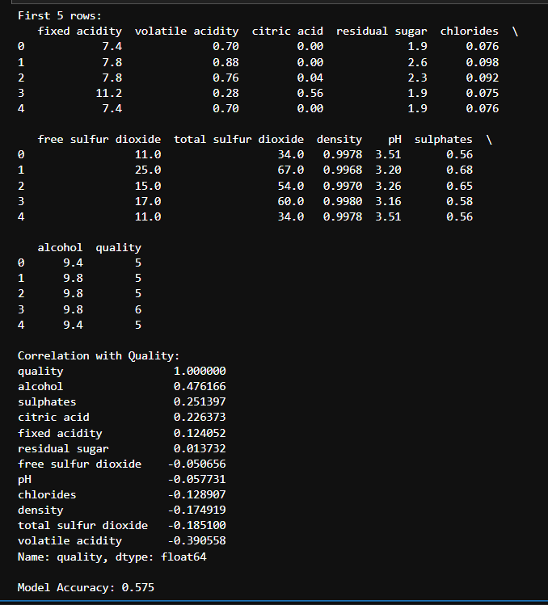

Q4. On Syllabus record: Basics of Unsupervised Learning, Different Models of Unsupervised Learning
- Aim: To apply K-Means clustering and PCA dimensionality reduction on unlabeled data.
- Materials Used: Python (scikit-learn), sample unlabeled dataset (e.g., Mall customers).
- Procedure: Load data, apply PCA for reduction, run K-Means with elbow method for k selection, evaluate silhouette score, visualize clusters.
- Result: Students gain insight into unsupervised pattern discovery and evaluation.
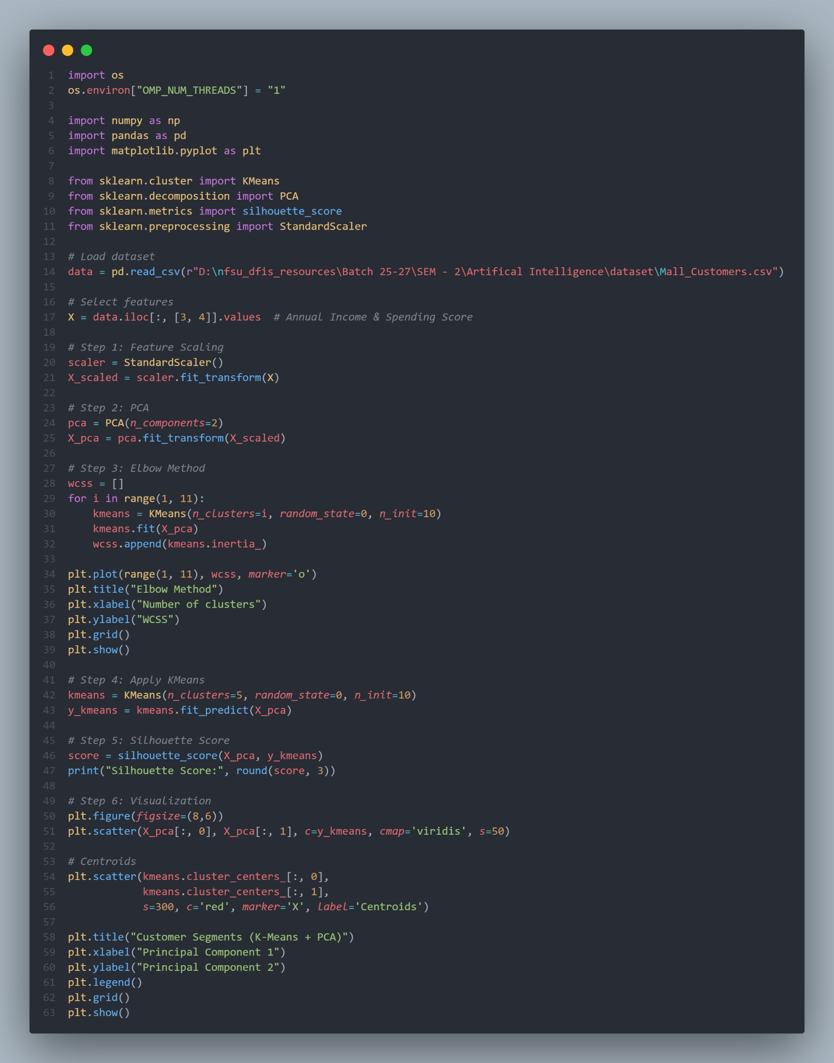
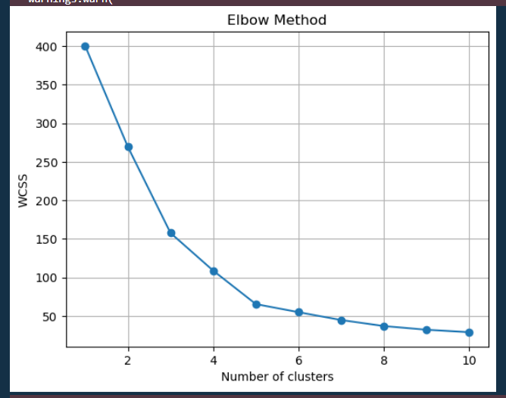

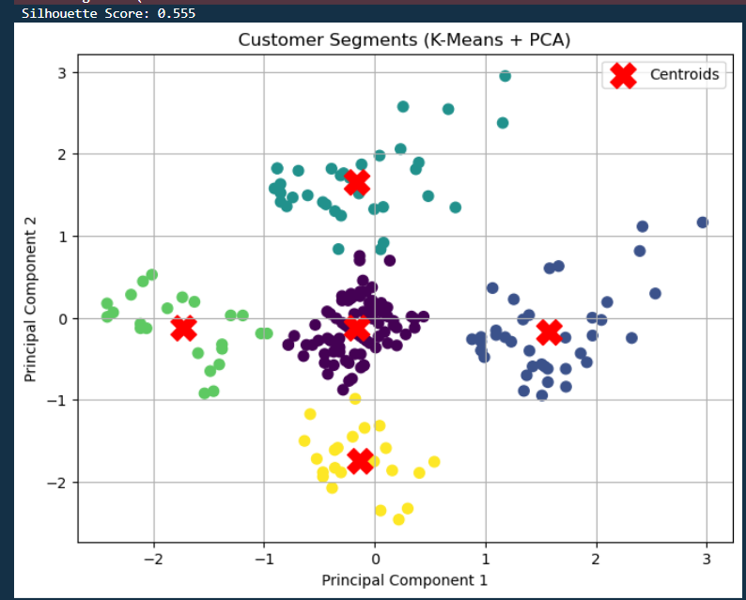
Q5. On Syllabus record: Defining & Building a Perceptron, Feed Forward, Back
propagation, Single-layer & Multi-layer ANNs
- Aim: To build and compare single-layer perceptron and multi-layer ANN with backpropagation on classification task.
- Materials Used: Python (Keras/TensorFlow), MNIST or synthetic binary dataset.
- Procedure: Code perceptron from scratch, build MLP with Dense layers and backprop, compile with binary crossentropy, train and plot loss curves.
- Result: Students comprehend evolution from perceptron to advanced ANN architectures.
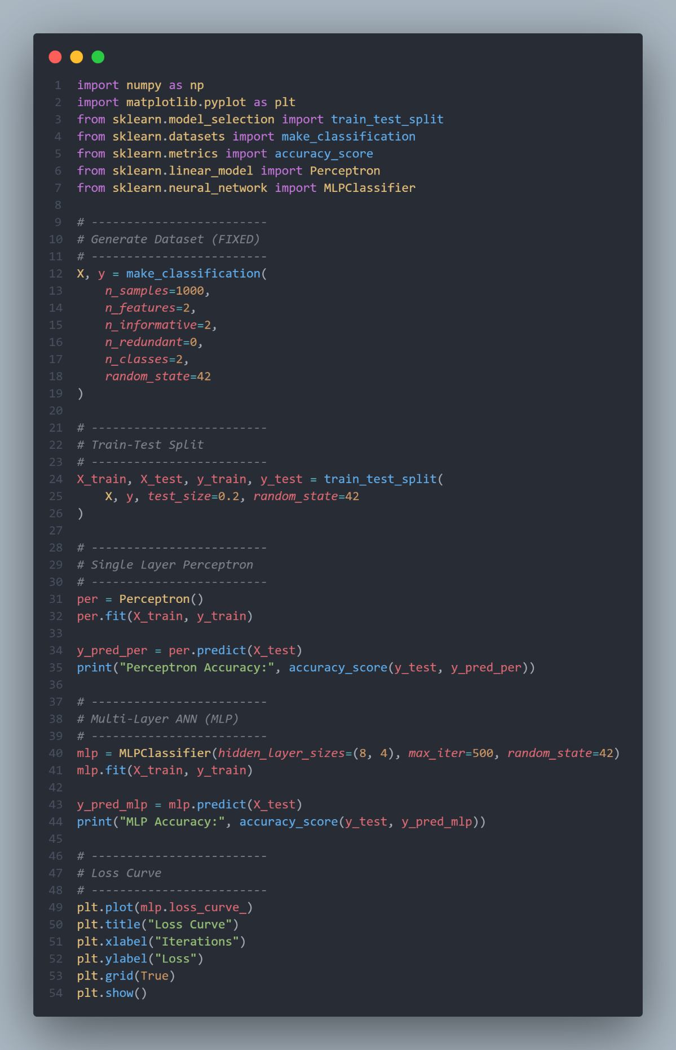
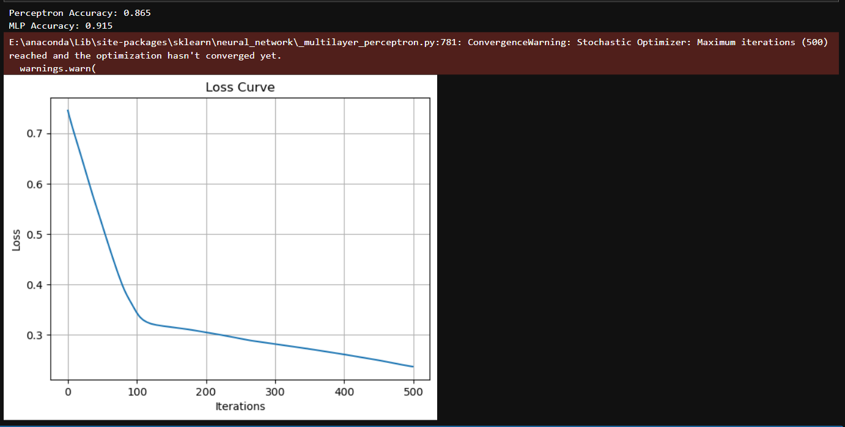

Q6. On Syllabus record: Convolutional Neural Networks (CNN), Building & Fitting
CNN Models
- Aim: To construct and train a CNN for image classification on a standard dataset.
- Materials Used: Python (Keras), CIFAR-10 dataset, Jupyter Notebook.
- Procedure: Load and preprocess images, build CNN with Conv2D/Pooling/Flatten/Dense, add Dropout, fit model, evaluate accuracy on test set.
- Result: Students learn CNN layers for feature extraction in image-based tasks.

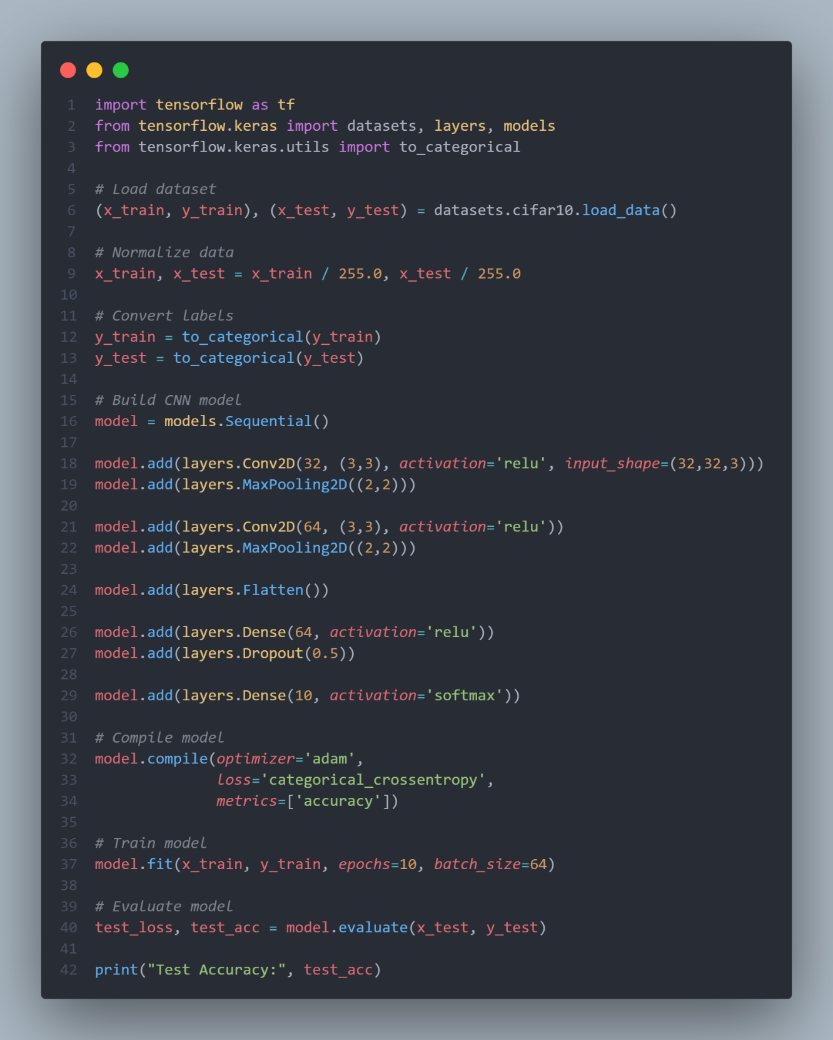

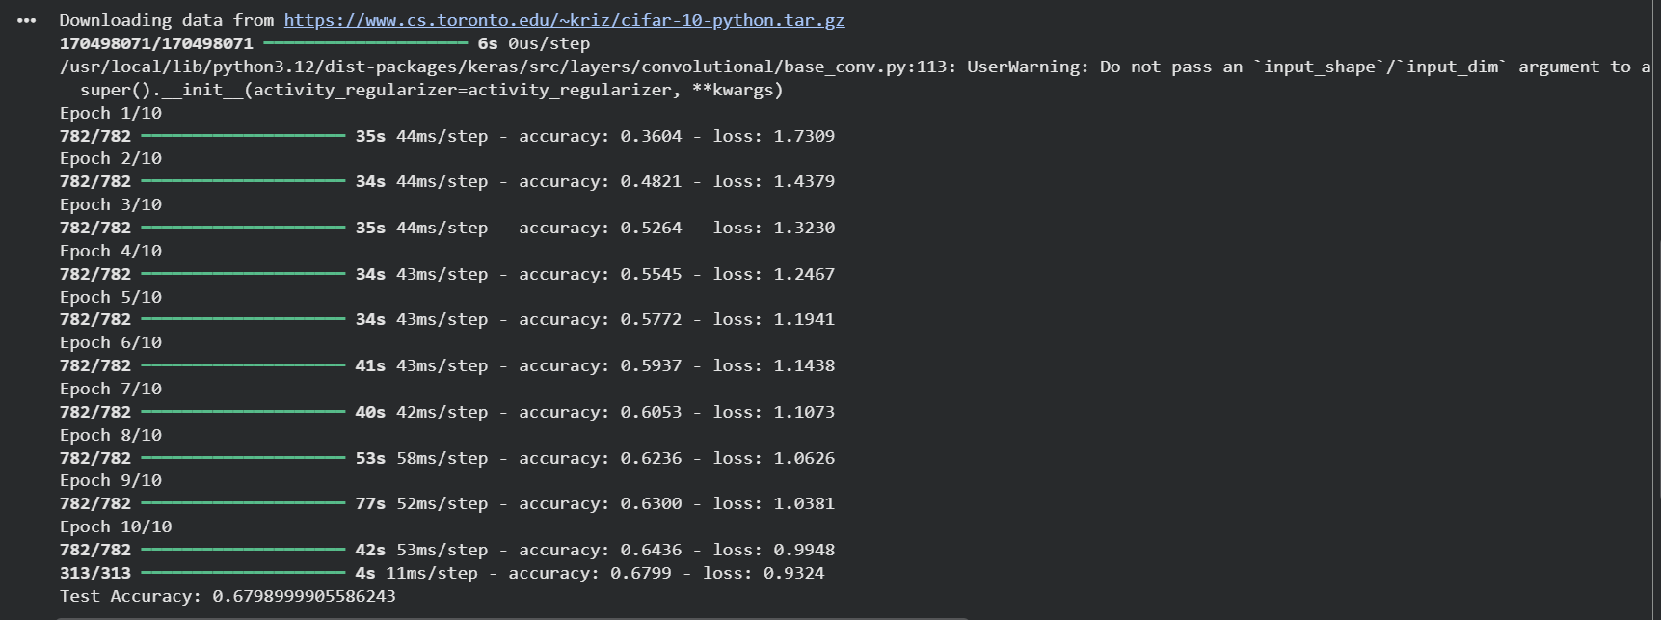
Q7. On Syllabus record: Computer Vision: Object Detection, Image Segmentation, Detecting Faces
- Aim: To implement face detection and basic object recognition using pre- trained models.
- Materials Used: Python (OpenCV, Haar cascades), sample images, webcam access.
- Procedure: Load Haar cascade classifier, detect faces in images/video, draw bounding boxes, segment detected regions, compute recognition metrics.
- Result: Students apply CV techniques for real-time object and face detection.

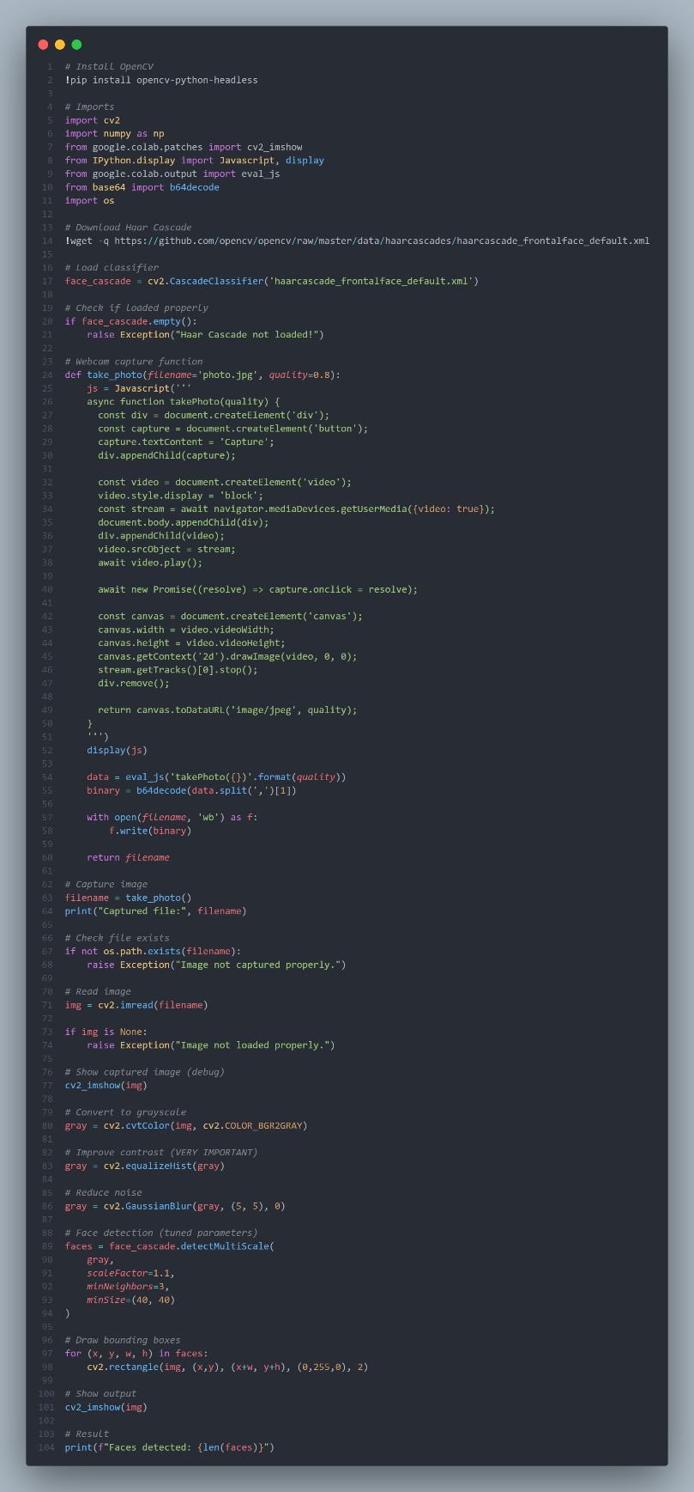

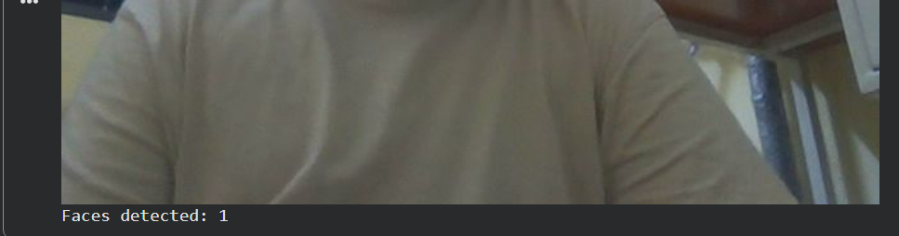

Q8. On Syllabus record: Natural Language Processing: Text Vectorization, Classification for Text Analysis
- Aim: To vectorize text data and build a sentiment classification model.
- Materials Used: Python (scikit-learn, NLTK), IMDB reviews or Twitter sentiment dataset.
- Procedure: Preprocess text (tokenize, remove stop words), apply TF-IDF vectorization, train Naive Bayes classifier, evaluate with confusion matrix.
- Result: Students understand text transformation for ML-based language analysis.

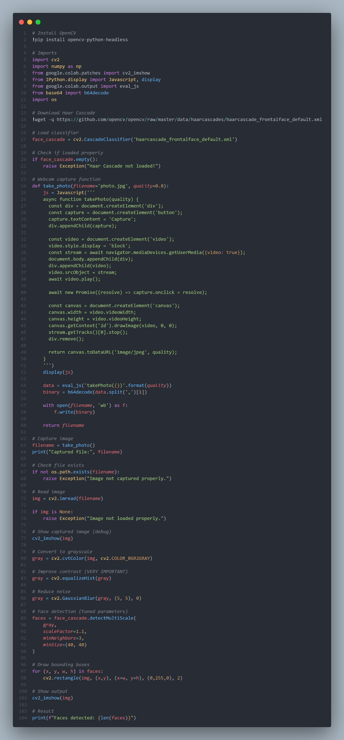
Output:
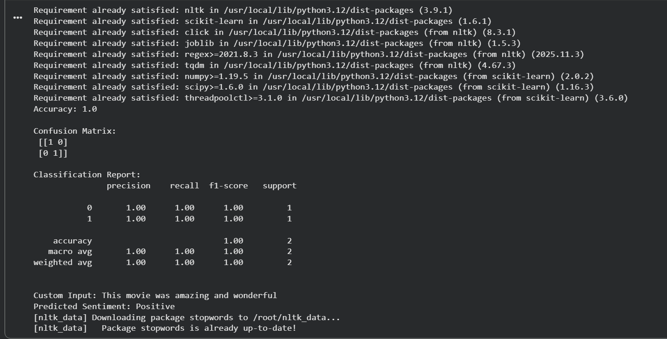

Q9. On Syllabus record: ML/DL for Cyber Security: Malware Detection & Classification
- Aim: To classify malware samples using supervised learning on static features.
- Materials Used: Python (scikit-learn, Pandas), public malware dataset (e.g., API calls CSV).
- Procedure: Load features/labels, handle imbalance with SMOTE, train Random Forest classifier, compute precision/recall/F1 for classes.
- Result: Students deploy ML for binary/multi-class malware identification.

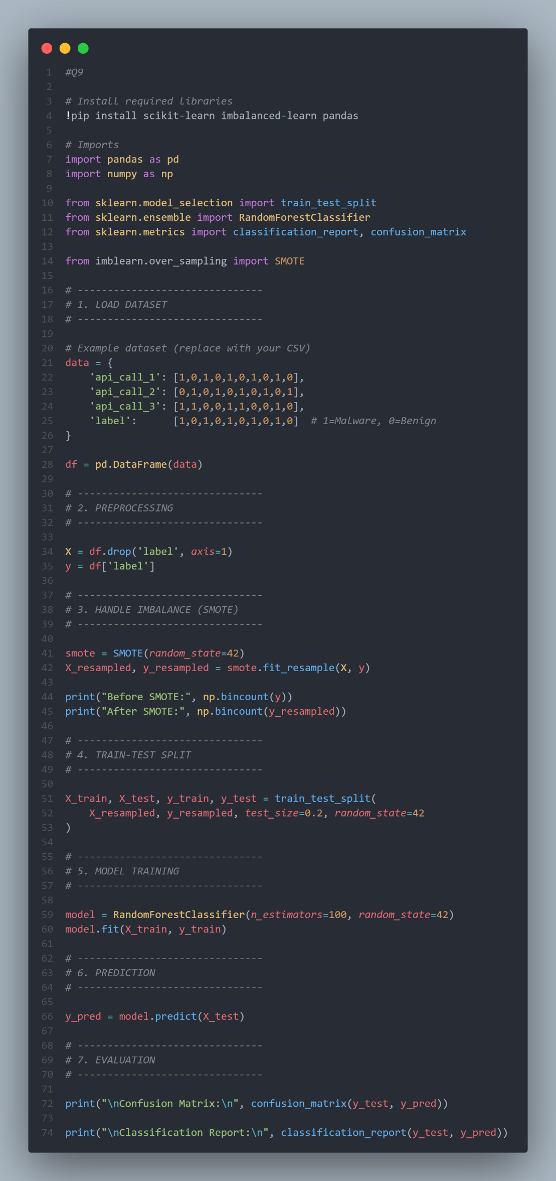
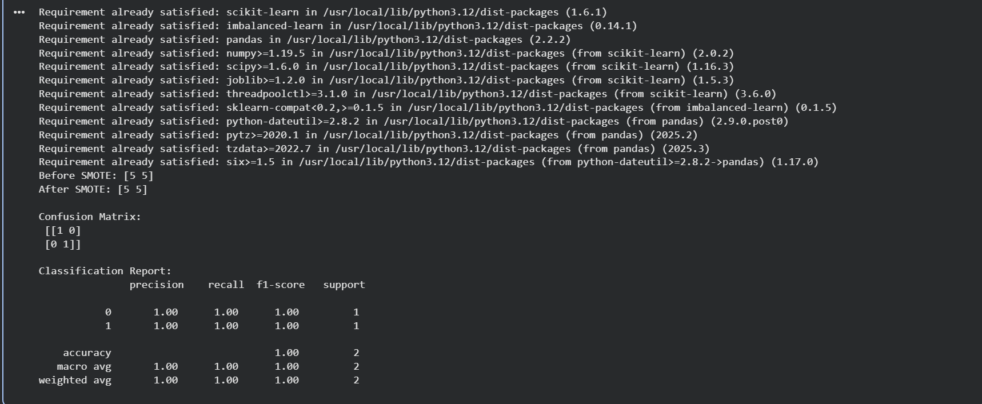

Q10. On Syllabus record: ML/DL for Cyber Security: Anomaly Detection, ML based
Intrusion Detection
- Aim: To detect anomalies in network traffic using Isolation Forest for intrusion detection.
- Materials Used: Python (scikit-learn), KDD Cup 99 or NSL-KDD dataset subset.
- Procedure: Load/preprocess network features, fit Isolation Forest model, predict anomalies, visualize contamination score and decision function.
- Result: Students implement unsupervised anomaly detection for cybersecurity monitoring.

